**TUGAS WEEK 5**

**HOMEWORK LAYOUTING UI**

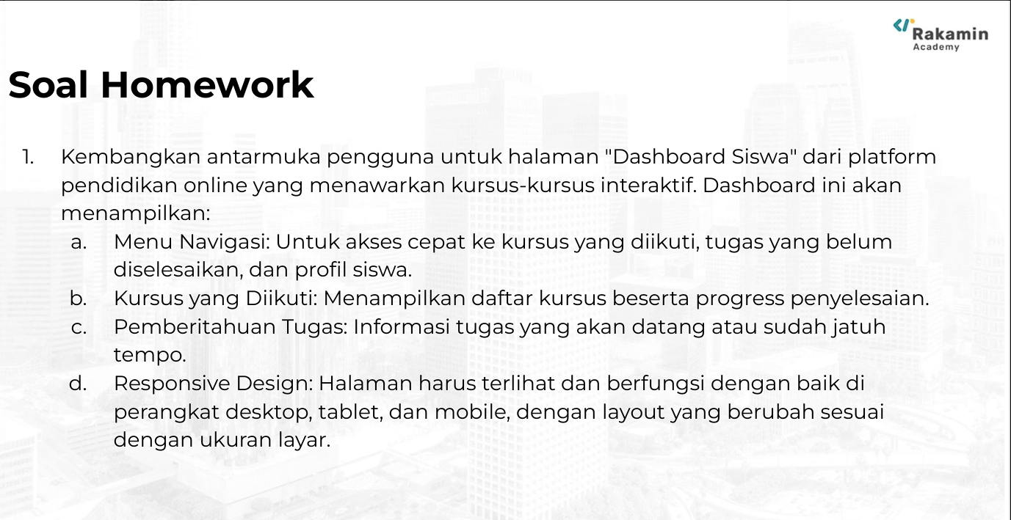

**ILHAM SAPUTRA**

**IT FULL STACK DEVELOPER**

**MSIB 7**

**Link Github :** [**https://ishasii.github.io/Web-Education-Layouting-UI/**](https://ishasii.github.io/Web-Education-Layouting-UI/)

**Link Repository : https://github.com/ISHASII/Web-Education-Layouting-UI.git**